**public** **class** Test {

**public** **static** **void** main(String[] args) {

System.***out***.println("20145165 정균모");

**int**[] arr = { 5, 9, 11, 15 };

**int**[] arr2 = (**int**[]) arr.clone();

System.***out***.print("[ 오리지널]");

*printArray*(arr);

System.***out***.print("\t[ 복사본]");

*printArray*(arr2);

System.***out***.println();

arr2[1] = 20;

*printHyphen*(58);

System.***out***.println("오리지널의 1번 인덱스의 값을 20으로 변경함");

System.***out***.println();

System.***out***.print("[ 오리지널]");

*printArray*(arr);

System.***out***.print("\t[ 복사본]");

*printArray*(arr2);

}

**static** **void** printHyphen(**int** num) {

**for** (**int** i = 0; i < num; i++) {

System.***out***.print("-");

}

System.***out***.println();

}

**static** **void** printArray(**int**[] arr) {

**for** (**int** i = 0; i < arr.length; i++) {

System.***out***.print(" "+arr[i]);

}

}

}

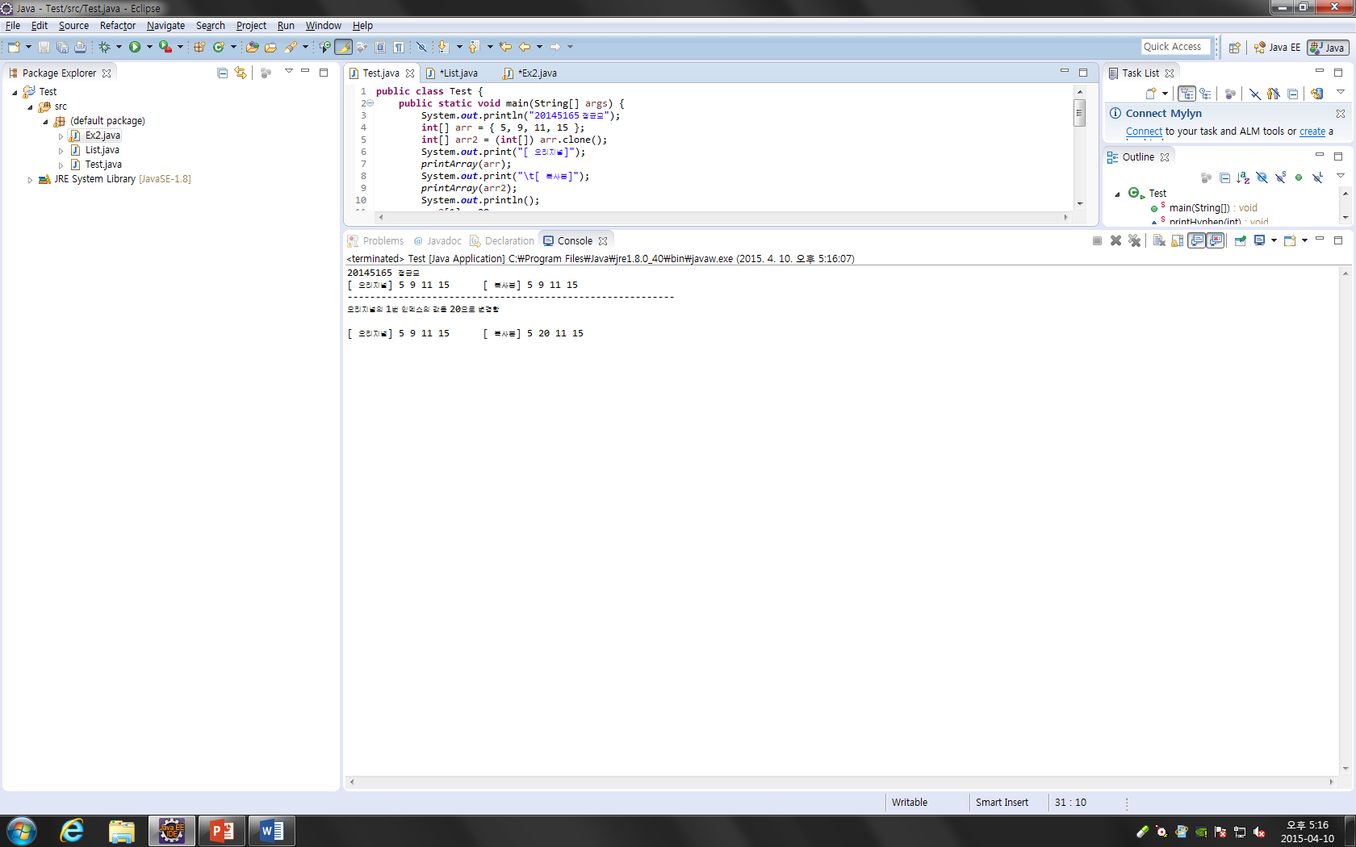

Main

**import** java.util.Scanner;

**public** **class** Ex2 {

**public** **static** **void** main(String[] args) {

// **TODO** Auto-generated method stub

Scanner scan = **new** Scanner(System.***in***);

List list = **new** List();

System.***out***.println("20145165 정균모");

**while** (**true**) {

System.***out***.println("List는 :");

list.printall();

System.***out***.println("메뉴를 선택하세요 : \n 0.isEmpty? \n 1.insert \n 2.length \n 3.search \n 4.replace \n 5.delete \n 6.exit");

**int** num = scan.nextInt();

**switch**(num){

**case** 0:

System.***out***.println(list.isEmpty());

**case** 1:

System.***out***.println("새로운 원소 j값을 입력하세요 :");

**int** j =scan.nextInt();

System.***out***.println("어디에 삽입하시겠습니까 :");

**int** k = scan.nextInt();

list.insert(j, k);

**break**;

**case** 2:

System.***out***.println(list.length());

**break**;

**case** 3:

System.***out***.println("몇 번째 자리를 출력하시겠습니까? :");

**int** se = scan.nextInt();

System.***out***.println(list.search(se));

**break**;

**case** 4:

System.***out***.println("교체할 원소를 입력하세요: ");

**int** item = scan.nextInt();

System.***out***.println("어떤 값과 교체하실껀가요 :");

**int** r = scan.nextInt();

list.replace(r, item);

**break**;

**case** 5:

System.***out***.println("제거할 값을 입력하세요: ");

**int** dele=scan.nextInt();

list.delete(dele);

**break**;

**case** 6:

**break**;

**default**:

System.***out***.println("잘못 입력하셨습니다 다시 입력하세요.");

**continue**;

}

}

}

}

List

**public** **class** List {

**private** **int** size = 0;

**private** **int**[] array = **new** **int**[100];

**public** **void** insert(**int** j, **int** k) {

**if**(k<=size){

**for**(**int** i = size; i>k; i--){

array[size] = array[size - 1];

}

array[k] = j;

size++;

}**else**

System.***out***.println("j값을 잘못 입력하셨습니다.");

}

**public** **boolean** isEmpty() {

**return** (size == 0);

}

**public** **int** length() {

**return** size;

}

**public** **int** search(**int** se) {

**return** array[se];

}

**public** **void** replace(**int** j, **int** item) {

**for** (**int** i = 0; i <= size; i++) {

**if** (array[i] == j)

array[i] = item;

}

}

**public** **void** delete(**int** j) {

**for** (**int** i = 0; i <= size; i++) {

**if** (array[i] == j) {

**while** (i <= size) {

array[i] = array[i + 1];

size--;

}

}

}

}

**public** **void** printall() {

**for** (**int** i = 0; i < size; i++) {

System.***out***.print(" " + array[i]);

}

}

}